

IBM HR Analytics employee attrition & performance

Data Analytics using Power BI



Aiolos Cloud Solutions

**Contents**

**Scope 3**

**Data Context: 3**

**Data Dictionary: 3**

**Objective: 4**

**Data Collection/ Extract: 5**

**Pre-Processing & Transformation: 5**

**Data Visualization: 6**

**Overview: 7**

**Job Profile: 7**

**Conclusion: 12**

**Table of Figures:**

Figure 1: Dataset loaded in Power BI 4

Figure 2: Data Visualization Panel 6

Figure 3: Overview page of the HR Analytics Dashboard 7

Figure 4: Job Profile page of HR Analytics Dashboard 8

Figure 5: Visual from Overview page (Pie Chart & Donut Chart) 8

Figure 6: Visual from Overview page (Bar Chart & Stack Bar Chart) 9

Figure 7: Visual from the Overview page (Stack Bar Chart & Bar Chart) 10

Figure 8: Visual from the Job Profile page (Pie Chart & Donut Chart) 10

Figure 9: Visual from the Job Profile page (Stack Bar Chart & Treemap Chart) 11

Figure 10: Visual from the Job Profile page (Stack Bar Chart & Bar Chart) 11

**IBM HR Analytics Employee Attrition & Performance**

Scope:

HR analytics, also known as people analytics, workforce analytics, or talent analytics, include collecting, analyzing, and reporting on HR data. It helps enterprise to assess the influence of various HR Goals on overall business results and make data-driven choices. HR analytics, in other terms, is a data-driven approach to Human Resources Management.

# Data Context:

In HR analytics, a data context basically provides any background information that gives a larger knowledge and perspective of an event, person, or thing. In this data, we get information on employee’s education, past experience, marital status, job roles/ designation, departments, salary, travel history, work satisfaction, their growth & much more depending on the organization & their requirements. This features assists organizations in analyzing traits and behaviors in order to provide a more distinct and personalized customer and employee experience. It may be obtained through the use of events, calendars, social media, location intelligence software, CRM practices, and a variety of other approaches, goods, or services.

# Data Dictionary:

|  |  |  |
| --- | --- | --- |
| **Variable** | **Meaning** | **Levels** |
| **Age** | Age of the employee |  |
| **Attrition** | Whether the employee left in the previous year or not |  |
| **BusinessTravel** | How frequently the employees travelled for business purposes in the last year |  |
| **Department** | Department in company |  |
| **DistanceFromHome** | Distance from home in kms |  |
| **Education** | Education Level | 1 'Below College' |
| 2 'College' |
| 3 'Bachelor' |
| 4 'Master' |
| 5 'Doctor' |
| **EducationField** | Field of education |  |
| **EmployeeCount** | Employee count |  |
| **EmployeeNumber** | Employee number/id |  |
| **EnvironmentSatisfaction** | Work Environment Satisfaction Level | 1 'Low' |
| 2 'Medium' |
| 3 'High' |
| 4 'Very High' |
| **Gender** | Gender of employee |  |
| **JobInvolvement** | Job Involvement Level | 1 'Low' |
| 2 'Medium' |
| 3 'High' |
| 4 'Very High' |
| **JobLevel** | Job level at company on a scale of 1 to 5 |  |
| **JobRole** | Name of job role in company |  |
| **JobSatisfaction** | Job Satisfaction Level | 1 'Low' |
| 2 'Medium' |
| 3 'High' |
| 4 'Very High' |
| **MaritalStatus** | Marital status of the employee |  |
| **MonthlyIncome** | Monthly income in rupees per month |  |
| **NumCompaniesWorked** | Total number of companies the employee has worked for |  |
| **Over18** | Whether the employee is above 18 years of age or not |  |
| **PercentSalaryHike** | Percent salary hike for last year |  |
| **PerformanceRating** | Performance rating for last year | 1 'Low' |
| 2 'Good' |
| 3 'Excellent' |
| 4 'Outstanding' |
| **RelationshipSatisfaction** | Relationship satisfaction level | 1 'Low' |
| 2 'Medium' |
| 3 'High' |
| 4 'Very High' |
| **StandardHours** | Standard hours of work for the employee |  |
| **StockOptionLevel** | Stock option level of the employee |  |
| **TotalWorkingYears** | Total number of years the employee has worked so far |  |
| **TrainingTimesLastYear** | Number of times training was conducted for this employee last year |  |
| **WorkLifeBalance** | Work life balance level | 1 'Bad' |
| 2 'Good' |
| 3 'Better' |
| 4 'Best' |
| **YearsAtCompany** | Total number of years spent at the company by the employee |  |
| **YearsSinceLastPromotion** | Number of years since last promotion |  |
| **YearsWithCurrManager** | Number of years under current manager |  |

# Objective:

HR analytics follows a pattern of gathering and analyzing data that can assist organizations in gaining critical insight into their activities. Overall, HR analytics follows a multi-step procedure to better understand their employees. With the help of the available dataset it will be easy to get the insight of the organizations employee’s data with respect to their qualifications, job roles, performance & salary.

## Data Collection/ Extraction:

One of the first tasks in HR analytics is to collect the relevant data. Employee profiles, performance, statistics on both high- and low-performers, employee demography, pay, promotions, development, adherence, engagement, retention, and turnover are all part of this data.

The data can be collected or stored on various platform such as cloud storage- AWS, Azure other database services such as SQL.

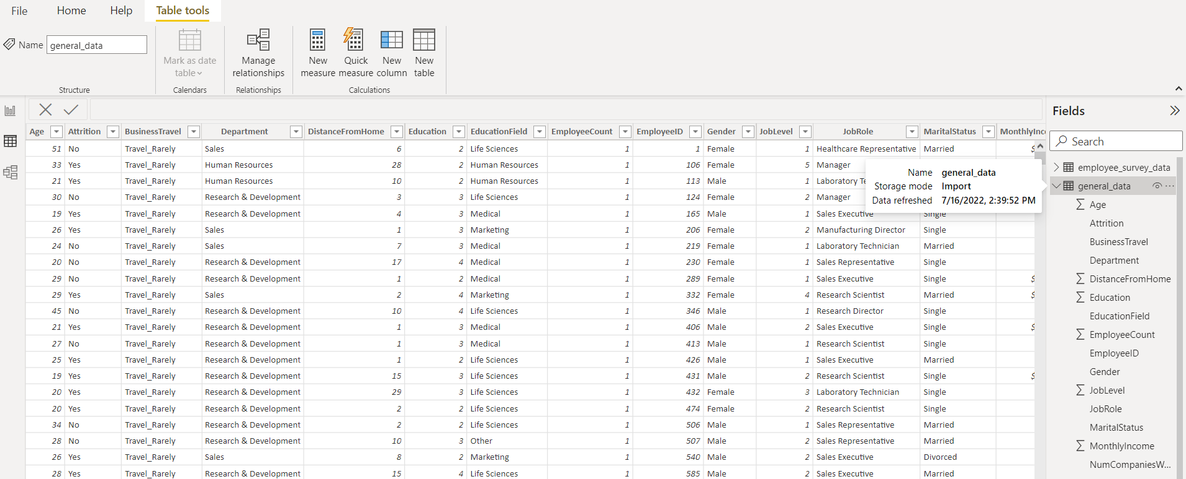

Figure 1: Dataset loaded in Power BI

The data used for this analytics is from the source Kaggle. Since the data is available on public domain to perform analytics practice, there is no requirement for ethical & piracy confirmation.

But if an organization needs to maintain their own records it could be made possible by using SQL. And with the help of the data extraction in Power BI by using authorized credential, the data can be extracted & loaded into the power BI to perform analysis & visualization.

By using Power BI, we can easily connect to these various data platform by having a valid account to access them. Once the connection is established, we can easily collect or extract data based on our needs.

## Pre-Processing & Transformation:

After a process of extracting the data, the data needs to be pre-processed & transformed into the accurate data in order to retrieve right insight from it. Any unwanted or undesired data can be removed from the records to avail the proper dataset.

In Power BI, with the help of Measures, DAX & other functionality we can easily clean & transform data on the need basis. Such as with the query use we can group or join columns to get right value to which one can create a new measure. With the help of DAX formula’s we can create new values as per the requirement such as YoY, MoM & QoQ values. We can even transform the data into the appropriate values such as conversion into currency, date hierarchy, etc.

Once the data is been processed & transform, it is ready to perform analysis & create visualization reports to finally draft dashboard. Even while performing analysis, one find to make some additional values/ measures, one can easily create new query measure in power BI which results in auto-update of the data. This results in faster accuracy & saves time.

# Data Visualization:

Below is the performed data visualization on the dataset available IBM HR Analytics Employee Attrition & performance. The data visualization is performed on the visualization tool called as Power BI.

The dashboard consist of various visuals that indicates various factors. The dashboard is divided into two prospects- Overview & Job Profile. Each page in dashboard demonstrated different values & insights from the data.

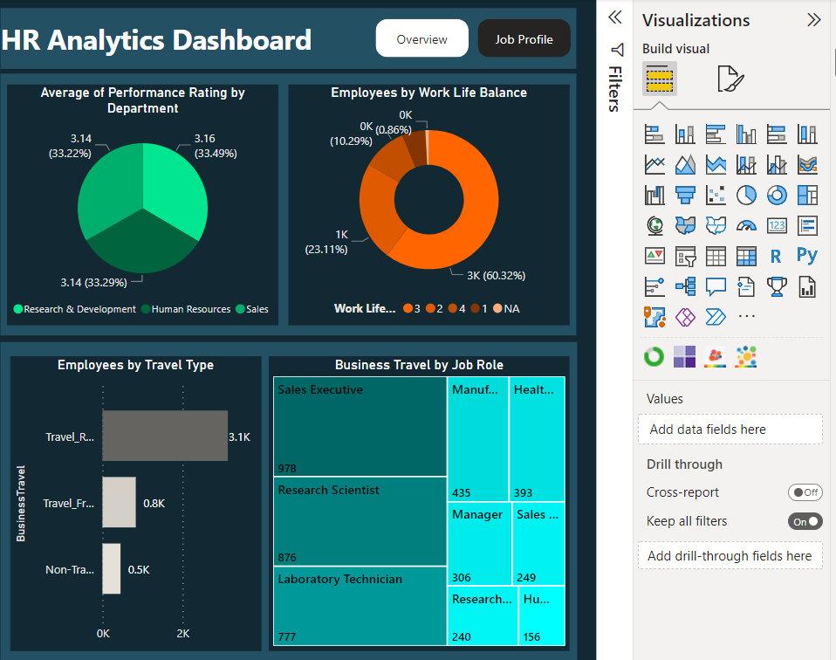

Figure 2: Data Visualization Panel

The dashboard is made with the various combination of graphs, filters, slicers, & buttons. The slicers can help in getting the insight based on the values set either in Age or Department or Attrition. On the top right corner of the dashboard there are two buttons which helps in switching the report based on the option chosen.

## Overview:

The Overview page shows visuals on Employees by Gender, Marital status of the employees, Number of employees with respect to the age, Employees Job roles, Employees Education level, Employees Salary hike, etc. Also, the page includes different valued KPI’s/ Cards such as Total Employee count, Average Age of the employees, Job satisfaction rating & total training hours invested in the employees.

While there is a constant filters set for both the pages which helps in getting the insights based on user’s needs. This filters are Age, Department level & Attrition type of the employee.

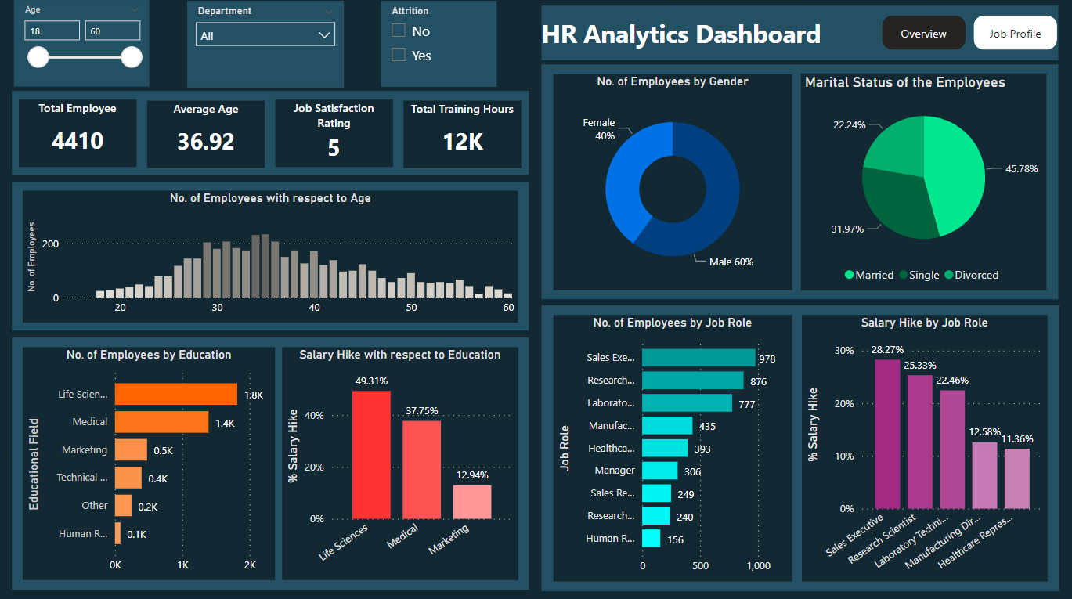

Figure 3: Overview page of the HR Analytics Dashboard

## Job Profile:

The Job Profile page shows visuals on Employees with respect to the Job Roles & Gender, Average Performance ratings by department, Ratings by employees by work life balance, Number of employees by departments, Employees Monthly income by Job Roles, Employees by Travel type, & Employees Business travel by Job Roles.

Also, the page includes different valued KPI’s/ Cards such as Total Employee count, Average Age of the employees, Average Monthly Income & Average percent salary hike in the employee’s salary.

While there is a constant filters set for both the pages which helps in getting the insights based on user’s needs. This filters are Age, Department level & Attrition type of the employee.

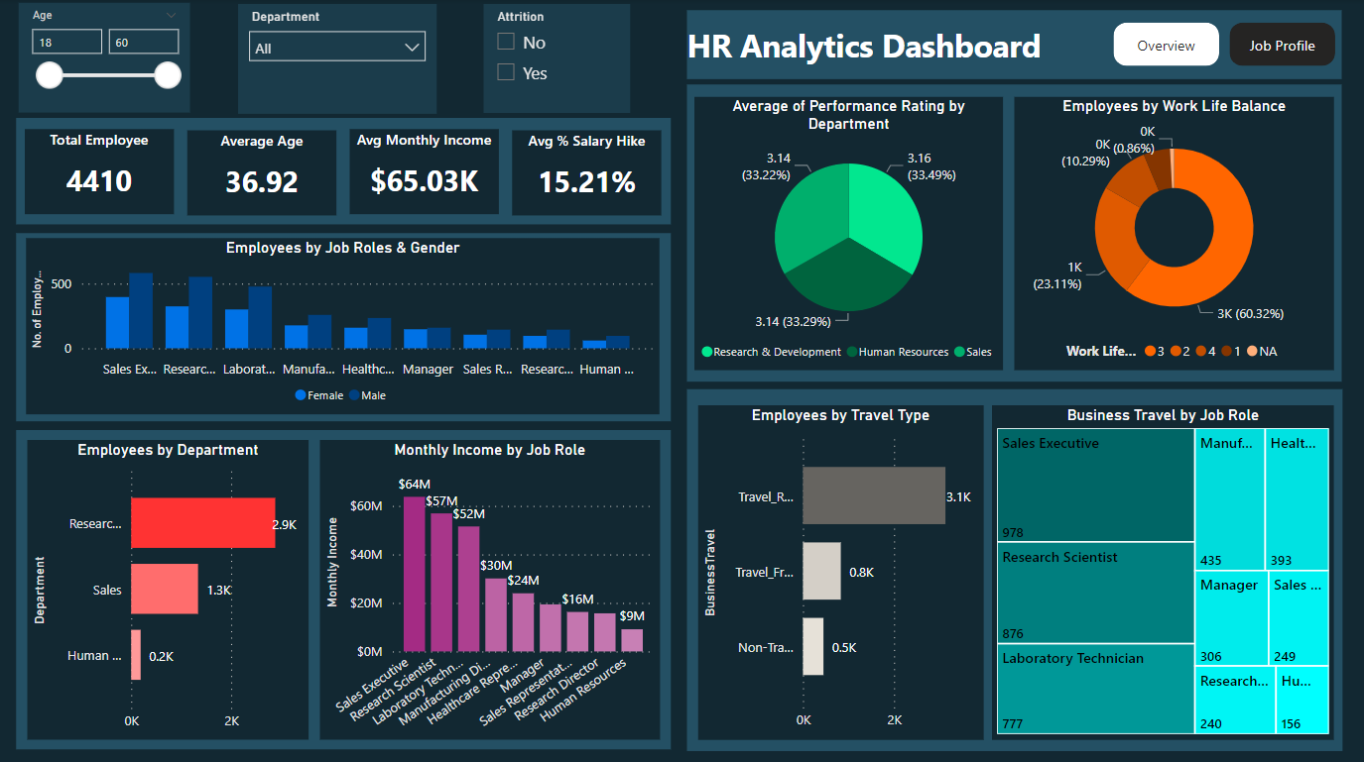

Figure 4: Job Profile page of HR Analytics Dashboard

1. The below visualization helps in understanding the number of employees that are female Y male. Also the visual helps in depicting the marital status of the total employees that are working in the organization. Below visualization is a donut chart & pie chart which makes it easy & clear to understand the value of each field.

* No. of Employees (Female)- 40% (donut chart)
* No. of Employees (Male)- 60% (donut chart)
* No. of Employees (Married)- 45.78% (pie chart)
* No. of Employees (Single)- 31.96% (pie chart)
* No. of Employees (Divorced)- 22.24% (pie chart)

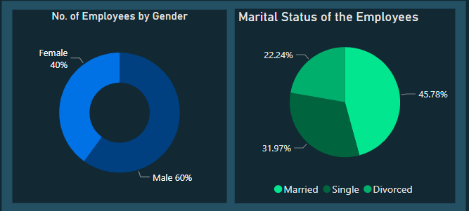

Figure 5: Visual from Overview page (Pie Chart & Donut Chart)

1. Below visual includes cards with appropriate values that highlights the main value to the viewer. It has bar graph & stack bar plot that indicates different comparison & values.

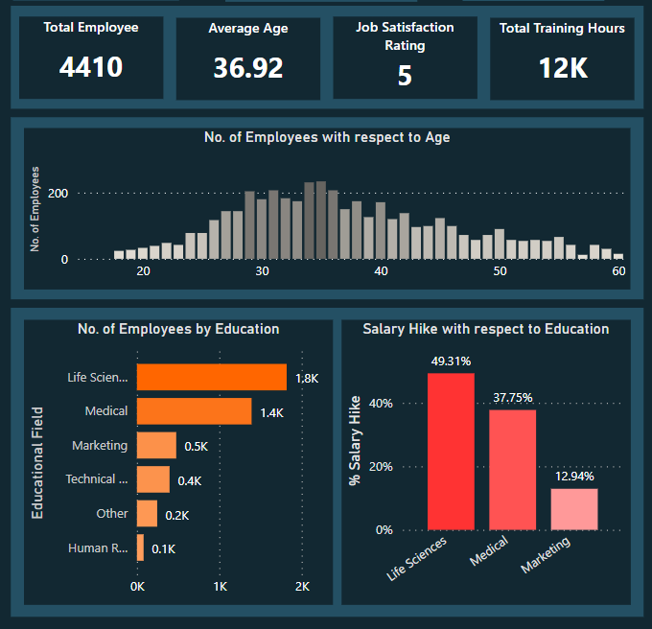

Figure 6: Visual from Overview page (Bar Chart & Stack Bar Chart)

1. The below visual (stack bar chart & bar chart) represent the data on No. of employees by job roles & the salary hike by job roles. It is easier to see the impact of job role on salary hike & how many employees work in which designations.

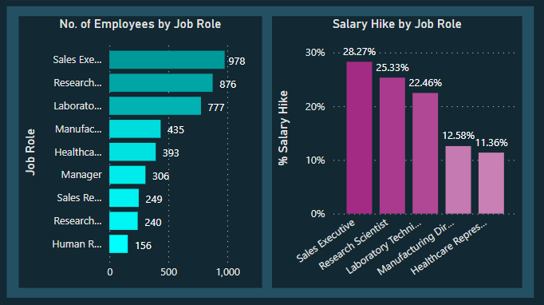

Figure 7: Visual from the Overview page (Stack Bar Chart & Bar Chart)

1. The below pie chart helps in demonstrating the average performance rating at department level which helps in justifying which department works on good level. While another pie chart helps in understanding the employees work life balance with respect to their ratings shared by them in one of the survey.

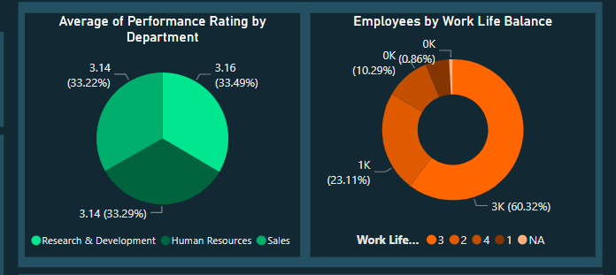

Figure 8: Visual from the Job Profile page (Pie Chart & Donut Chart)

1. The below visual helps in understanding travel history of the employees. On the left side stack bar chart helps in knowing how many employees travel frequently, how many travels rarely & how many don’t travel. While the tree map chart shows how many employees of different designations travels more for business related travels.

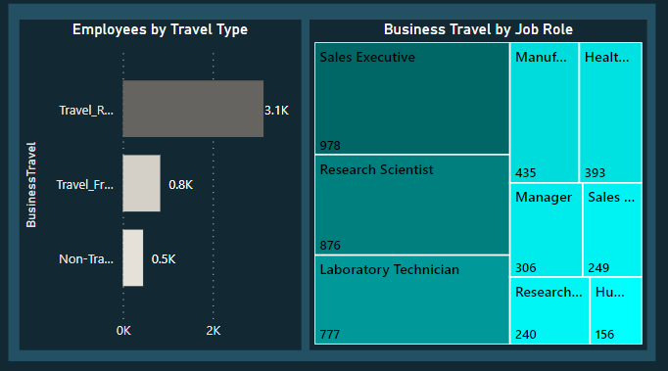

Figure 9: Visual from the Job Profile page (Stack Bar Chart & Tree map Chart)

1. The below visual helps in understanding number employees working in different department & roles with respect to gender & also the monthly income of employees by job roles.

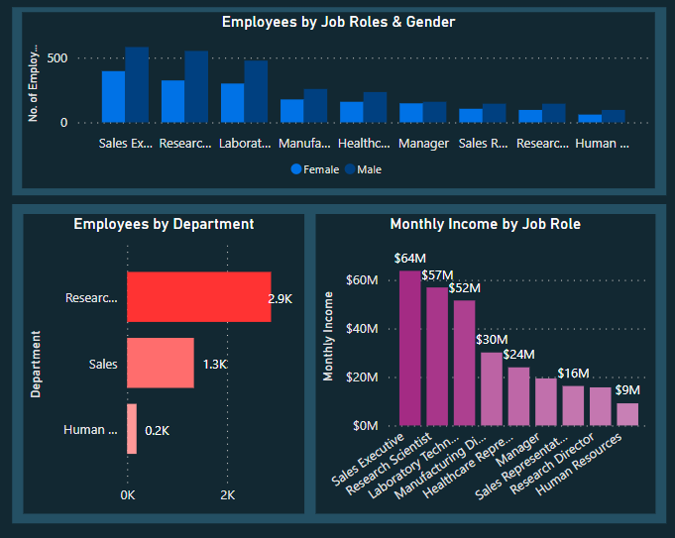

Figure 10: Visual from the Job Profile page (Stack Bar Chart & Bar Chart)

# Conclusion:

HR Analytics does not imply the purchase of expensive software, the formation of a large team, or the implementation of lengthy processes. You may begin by having talks with workers, recording their replies, involving various roles, developing a strategy, sharing it with everyone, and committing to it. It is critical to share data so that everyone is aware of it, understands it, and can contribute suggestions to improve the work experience. Use the data to drive projects, solve current issues, and effect good change in the organization. HR Analytics will assist you in monitoring and improving employee engagement, retention, wellness, productivity, experience, and work culture.